- Study About Moleculer Architecture in deep about how it works and apart from above features whatother features it can offer for an api.

* What is Moleculer ?
-> Moleculer is a fast, modern and powerful microservices framework for Node.js. It helps you to build efficient, reliable & scalable services. Moleculer provides many features for building and managing your microservices.

* Features

- request-reply concept
- Promise-based Solution(async/ Await Compatible)
- support event driven architecture with balancing
- built-in service registry & dynamic service discovery
- load balanced requests & events (round-robin, random, cpu-usage, latency, sharding)
- many fault tolerance features (Circuit Breaker, Bulkhead, Retry, Timeout, Fallback)
- plugin/middleware system
- support versioned services
- support Streams
- service mixins
- built-in caching solution (Memory, MemoryLRU, Redis)
- pluggable loggers (Console, File, Pino, Bunyan, Winston, Debug, Datadog, Log4js)
- pluggable transporters (TCP, NATS, MQTT, Redis, NATS Streaming, Kafka, AMQP 0.9, AMQP 1.0)
- pluggable serializers (JSON, Avro, MsgPack, Protocol Buffer, Thrift)
- pluggable parameter validator
- multiple services on a node/server
- master-less architecture, all nodes are equal
- parameter validation with fastest-validator
- built-in metrics feature with reporters (Console, CSV, Datadog, Event, Prometheus, StatsD)
- built-in tracing feature with exporters (Console, Datadog, Event, Jaeger, Zipkin)
- official API gateway, Database access and many other modules…

Architecture

From the architectural point-of-view the online store can be seen as a composition of 2 independent services: the products service and the gateway service. The first one is responsible for storage and management of the products while the second simply receives user´s requests and conveys them to the products service.

Now let’s take a look at how this hypothetical store can be created with Moleculer.
To ensure that our system is resilient to failures we will run the products and the gateway services in dedicated nodes (node-1 and node-2). If you recall, running services at dedicated nodes means that the transporter module is required for inter services communication. Most of the transporters supported by Moleculer rely on a message broker for inter services communication, so we’re going to need one up and running. Overall, the internal architecture of our store is represented in the figure below.

Now, assuming that our services are up and running, the online store can serve user’s requests. So let’s see what actually happens with a request to list all available products. First, the request (GET /products) is received by the HTTP server running at node-1. The incoming request is simply passed from the HTTP server to the gateway service that does all the processing and mapping. In this case in particular, the user´s request is mapped into a listProducts action of the products service. Next, the request is passed to the broker, which checks whether the products service is a local or a remote service. In this case, the products service is remote so the broker needs to use the transporter module to deliver the request. The transporter simply grabs the request and sends it through the communication bus. Since both nodes (node-1 and node-2) are connected to the same communication bus (message broker), the request is successfully delivered to the node-2. Upon reception, the broker of node-2 will parse the incoming request and forward it to the products service. Finally, the products service invokes the listProducts action and returns the list of all available products. The response is simply forwarded back to the end-user.

Flow of user’s request

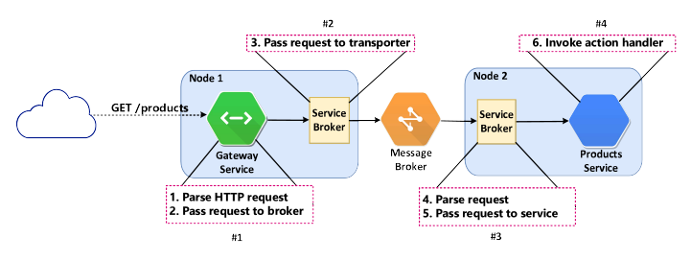
All the details that we’ve just seen might seem scary and complicated but you don’t need to be afraid. Moleculer does all the heavy lifting for you! You (the developer) only need to focus on the application logic.

Other Features that Moleculer Provides
- Action hooks : Action hooks are pluggable and reusable middleware functions that can be registered before, after or on errors of service actions. A hook is either a Function or a String. In case of a String it must be equal to service’s method name.

- Registering Service to a gateway
- Circuit Breaker
- Load Balacing
- Api Limiter
- Winston Logging
- Communication between Different Services
- There are two types of Services
1) Local Services : Two(or more) Services running on a single node are considered local services. They share hardware resources and use local bus to communicate with each other, no network latency(Transporter is not used.
2) Remote Services : Services distributed accross multiple nodes are considered remote. In this case, the communication is done via transporter.

- Communication between nodes are done via actions and events .

Actions :

- We called actions of diffrent services via context and broker object.
- To call a service using brocker called brocker.call method. The broker looks for service(and a node) which has given action and call it. The function returns a Promise.
- Syntex: const res = await broker.call(actionName, params,opts).
- The actionName is a dot-separated string. The first part of it is the service name, while the second part of it represents the action name. So if you have a posts service with create action, you can call it as posts.create.
- The params is an object which is passed to the action as a part of the Context. The service can access it via ctx.params. It is optional. If you don’t define, It will be {}.
- The opts is an object to set/override some request parameters e.g.: timeout , retrycount. It is optional.
- Available Calling Options
Name | Type | Default | Description
timeout | Number | null | Timeout of request in milliseconds. If the request is timed out and you don’t define fallbackResponse, broker will throw a RequestTimeout error. To disable set 0. If it’s not defined, the requestTimeoutvalue from broker options will be used.
retries | Number | null | Count of retry of request. If the request is timed out, broker will try to call again. To disable set 0. If it’s not defined, the retryPolicy.retries value from broker options will be used.
fallbackResponse | Any | null | Returns it, if the request has failed.
nodeID | String | null | Target nodeID. If set, it will make a direct call to the specified node.
meta | Object | {} | Metadata of request. Access it via ctx.meta in actions handlers. It will be transferred & merged at nested calls, as well.
parentCtx | Context | null | Parent Context instance. Use it to chain the calls.
requestID | String | null | Request ID or Correlation ID. Use it for tracing.

- Examples :

Call Without Params :
const res= await broker.call(“user.list”);

Call with params :
const res = await brocker.call(“user.recommendation”,{limit : 5},
timeout : 500,
retries : 3,
fallbackResponse : defaultRecommendation
});

Call With Promise Error handling
broker.call(“posts.update”,{id:2, title:”modified post title})
.then(res => console.log(“Post Updated”)
.catch(err => console.error(“unable to update post!”,err));

Direct Call : get Health into from the node-21 node
const res = await broker.call(“$node.health”, null ,{nodeID: “node- 21”});

- Calling multiple actions at the same time is also possible. To do it use broker.mcall or ctx.mcall.

mcall with Array<Object>
await broker.call(
[
posts:{action : ‘posts.find’, params:{author : 1}, options: {}},
users:{action : ‘users.find’, params:{name : ‘john’}}
],
{
// Common calling options for all calls.
meta : { token : ‘63f20c2d-8902-4d86-ad87-b58c9e2333c2’}
}
);

mcall with Object
await broker.call(
{
posts:{action : ‘posts.find’, params:{author : 1}, options: {}},
users:{action : ‘users.find’, params:{name : ‘john’}}
},
{
// Common calling options for all calls.
meta : { token : ‘63f20c2d-8902-4d86-ad87-b58c9e2333c2’}
}
);

Events :

- Broker has a built-in event bus to support Event-driven architecture and to send events to local and remote services.
- There are two types of events.
1) Balanced Events : The Event Listners are arranged to logical groups. It means that only one listener is triggered in every group.
Example :
you have 2 main services : users & payments. Both subscribe to the user.created event. You start 3 instances of users Service and 2 instances of payments Service. When you emit user.created event, only one users and one payments service instance will receive the event.
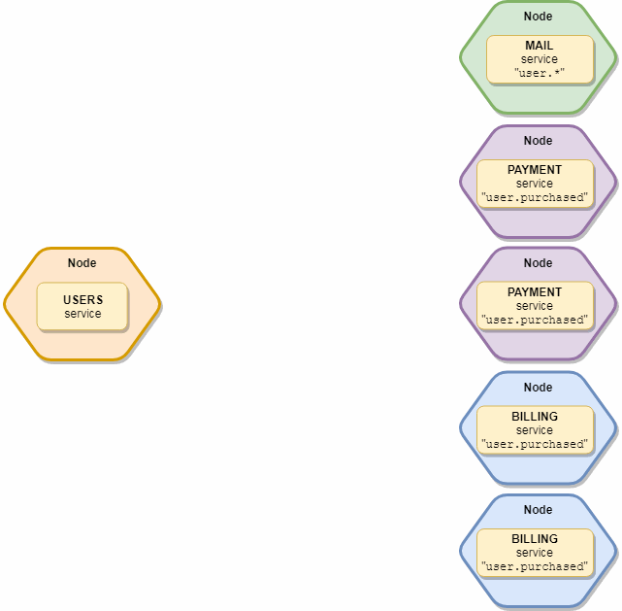

To Emit balanced Events, send Balanced events with broker.emit function. The First Parameter is the name of the event and second parameter is payload. To send multiple values, wrap into an object.
Example :

// The user will be serialized to transportation
broker.emit(“user.created”,user);

// Specify which groups/services shall receive the event
// Only the mail and payments services receive it
broker.emit(“user.created”, user, [“mail”, “payments”]);

2) Broadcast event : The Broadcast event is sent to all available local and remote services. It is not balanced, all service instances will receive it.

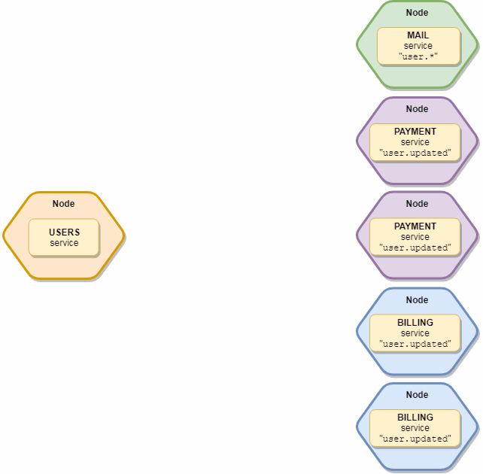

- Implement Custom MiddleWares
- Error Handling
- Timeout Handling

